# ATM SOFTWARE

Submitted in partial fulfillment of the requirements of

**University of Mumbai**

For the Degree of

## Bachelor of Engineering in CSE (AIML)

Submitted by

**Mr. Sufiyan Chougule [Roll No.: 6]**

## Mr. Vivek Kumbhar [Roll No.:21]

## Mr. Nimesh Kuthe [Roll No.: 23]

Under the guidance of

## Prof. Bhagyalakshmi



**DEPARTMENT OF CSE (AIML/IOT)**

**SMT. INDIRA GANDHI COLLEGE OF ENGINEERING**

Ghansoli, Navi Mumbai - 400701

## Academic Year: 2022-2023

## Declaration

We declare that this written submission represents our own ideas in our own words and where others ideas or words have been included; we have adequately cited and referenced the original sources. We also declare that we have adhered to all principles of academic honesty and integrity and have not misrepresented or fabricated or falsified any act/data/source in our submission. We understand that any violation of the above will be cause for disciplinary action by the Institute and can also evoke penal action from the sources which have thus not been properly cited or from whom proper permission has not been taken when needed.

**Sufiyan Chougule [06]**

**Vivek Kumbhar [21]**

**Nimesh Kuthe [23]**

nnn

Date: 12/10/2021

Place: Ghansoli, Navi Mumbai.

**Project Report Approval for OOPM**

This project report entitled “**ATM SOFTWARE”**

By

**Mr. Sufiyan Chougule [Roll No.: 6]**

**Mr. Vivek Kumbhar [Roll No.:21]**

## Mr. Nimesh Kuthe [Roll No.: 23]

are approved for the subject Object-Oriented Programming with Java, Semester III, University of Mumbai.

Prof. Bhagyalakshmi

Subject Teacher

Date: 12 /10/2021

Place: Ghansoli, Navi Mumbai.

**Abstract**

The ATM Software Android Application also phrased as ATM Simulation Software provides a basic simulation of a working Automatic Teller Machine

and educates the user about how exactly the main functions of an ATM work.

The user will have a better grasp and a basic idea of the functions of a real ATM

after using the application, making it easier for him/her to undergo the real transactional process. Functions such as entering the PIN Number for starting the session, Viewing the stored Balance as it changes with each transaction, Depositing and Withdrawing Cash via the ATM and its effect on the net balance of the bank account are successfully simulated in the Android Application.

**Table of Contents**:

|  |  |
| --- | --- |
| 1. | **Introduction:**   1. Objectives 2. Scope of the work 3. Block Diagram |
| 2. | **Design/Implementation:**   1. About the Basic Application 2. Source Code: XML and Java files |
| 3. | **Result and Analysis** |
| 4. | **References** |

**1. Introduction:**

1. **Objectives:**

* Designing of user interface that provides the user an idea of basic interface of an ATM System.
* To make the user well-accustomed to the functions of an ATM on a dummy simulation platform.

1. **Scope of the Work**:

The scope of the project depends upon the intended activity to be performed using the simulation software.

The application can either be used by new users to get a basic idea of the ATM System before the use of a real ATM or it can be used by curious students who are not yet permitted to use an ATM to attain a glimpse of the functions of PIN Entry, Balance viewing, money Withdrawal and Deposit.

Thus, the scope for this project lies within the boundaries of educational purposes. It can not be used as an ideal platform to understand other deep concepts regarding the Banking System and nor as an alternative to any real cash transaction systems.

1. **Block Diagram:**

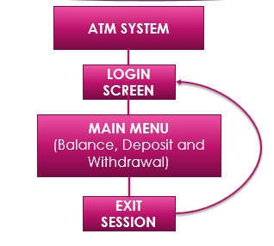

**2. Design/Implementation:**

1. **About the Basic Application:**

Platform Used for Designing: **Android Studio Version 11.0.12**

While developing an application in Android Studio, the display structure and the backend functions are divided into two parts.

The display is handled by .xml files which contain **XML code** according to the required display and the backend functions for the app are handled by the .java classes (activities) which consist of appropriate **Java code** for performing each function.

As we have designed our application to be a multi-screen application consisting of two screens namely, **Login Screen** and **Main Menu**, we required two .xml files for structuring display and two .java activities for defining functions.

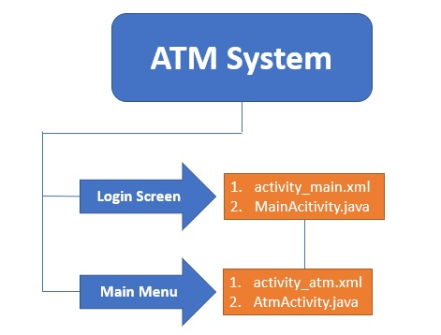

**1.activity_main.xml:**

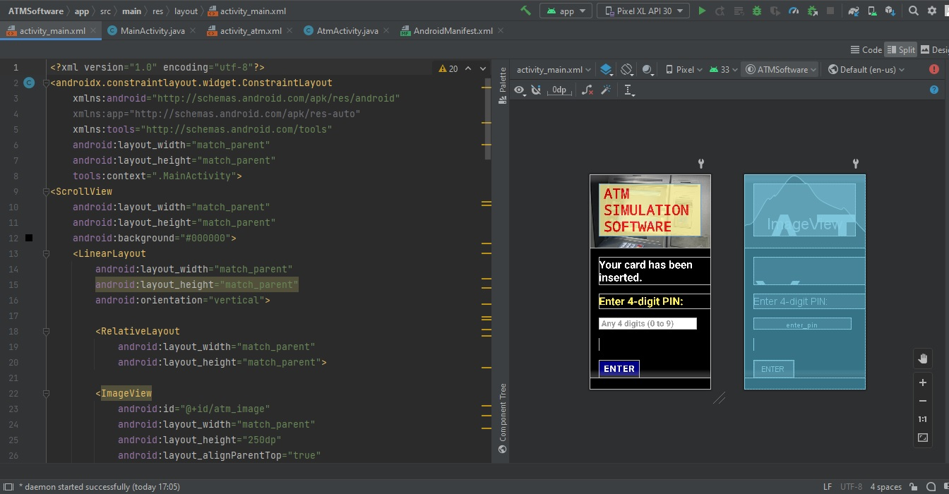

**2.MainActivity.java**

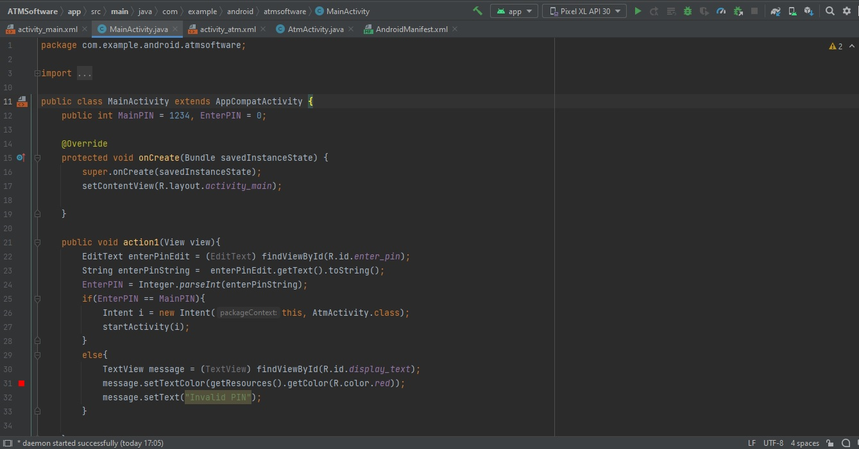

**1.activity_atm.xml**

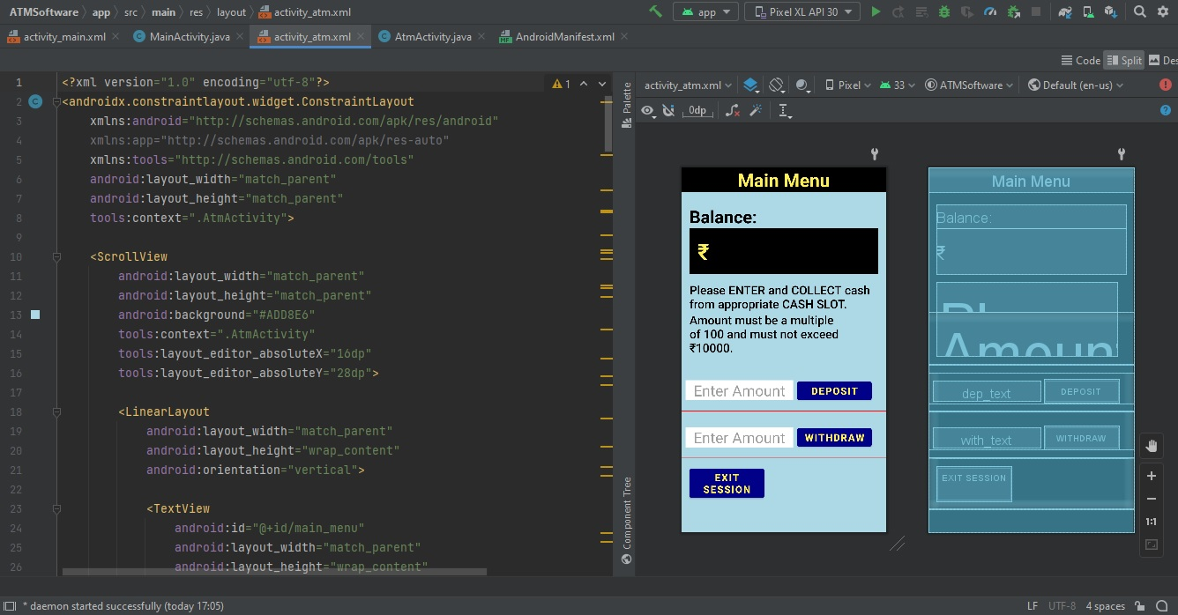

**2.AtmActivity.java**

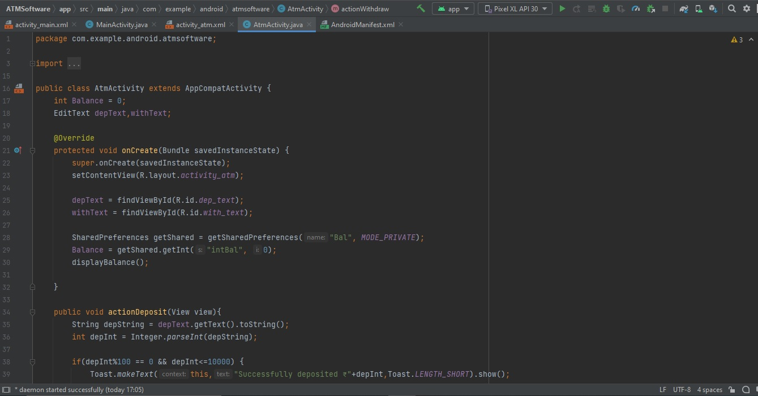

1. **Source Code:**

All Source Code files are available on:

<https://github.com/Sufi-san/Android-Development/tree/master/ATMSoftware>

**3. Result and Analysis:**

**Basic Structure and Functioning:**

The application starts with the first screen/activity **(Login Screen)** of entering the correct **PIN** number to access the second transactional activity.

If it is correct, we move on to the second activity.

The second activity **(Main Menu)** consists of **Balance Display**, two Enter Amount Fields and three buttons. **Deposit** button adds amount entered by user to the Balance while **Withdraw** button subtracts entered amount from the Balance.

The third button that is **Exit Session**, takes the user back to the Login Screen.

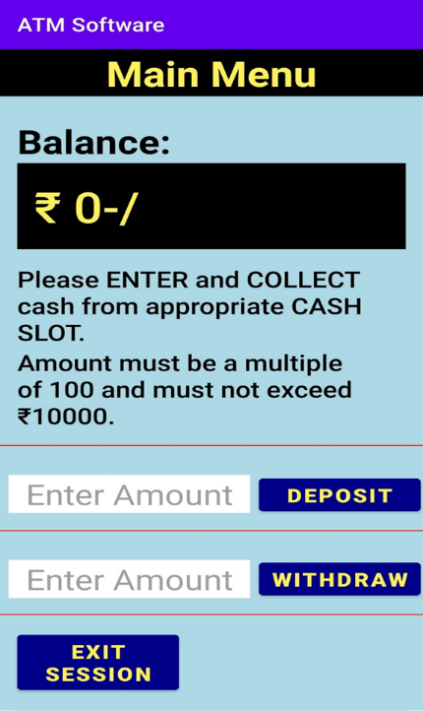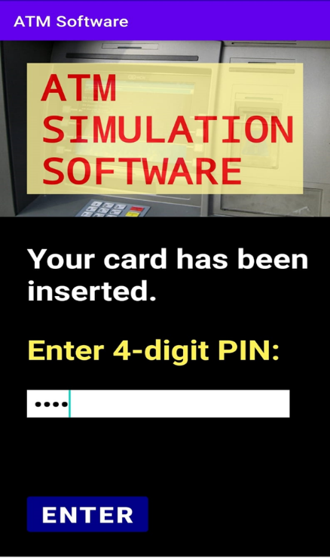

**Other important details:**

If entered PIN is incorrect, Invalid PIN is displayed on the screen.

If transaction amount exceeds 10000, is not a multiple of 100 or if withdraw amount is more than Balance, toast messages are displayed accordingly.

If there is no input by user and button is pressed, appropriate toast messages are displayed.

Any screen cannot be accessed again by pressing the back button in the phone, if tried, user exits the app.

**4. References:**

* Official Android Developers Website:

<https://developer.android.com/>

* Udacity Android Development Courses:

<https://learn.udacity.com/>

* CodeWithHarry Youtube Channel:

<https://www.youtube.com/watch?v=pO70tQ2kgoo>

* Stack Overflow Website:

https://stackoverflow.com/